eZ Flow

User Handbook
version 1.0



Table of Contents
1.Introduction 3
1.1.Typographical conventions 3
1.2.More resources 3
1.3.Training and certification 3
1.4.Contacting eZ 3
2.Zone and Block management 4
2.1.Zones 4
2.2.Creating blocks 4
2.2.1.Overflow 5
2.2.2.Block templates 5
2.2.3.Automatic rotation 6
2.2.4.Block position 6
2.3.Adding content 7
2.3.1.Adding content to a block 7
3.Preview 7
4.Glossary 8

Introduction
eZ Flow is an extension to eZ Publish that has extended functionality for handling the flow of content publication over time, specifically the rotation and placement of content on frontpages. Typical usage is a newspaper frontpage or managing a TV station’s portal. eZ Flow is ideal in situations where content changes quickly and there are many changes per day. eZ Flow is design to enable editors to plan the “flow” of content on these pages.

Target audience
This document explains how to use eZ Flow to create frontpages and portals, and is appropriate for site editors. For information about configuring eZ Flow, refer to the Configuration Guide.

Conventions
- Code samples, functions, variable names, and on are printed in monospace font.
- Filenames and paths are printed in monospace italic font.
- Commands are printed in monospace bold font.
- Elements of graphical user interfaces (such as buttons and field labels) are printed in bold font.
- Component names (such as an application) are capitalized, for example “Administration Interface”.
- In sample URLs, replace “example.com” with the domain name of your site.
- The screenshots in this document might have been modified to fit the page or to illustrate a point, and therefore might not exactly match the display on your site.

More resources
For assistance with eZ Publish, refer to the following resources:
- eZ Publish documentation: eZ Find is an extension to eZ Publish. Where appropriate, there are links in this document to the online versions of the eZ Publish documentation, located at http://www.ez.no/doc.
- eZ Publish forums: The forums on the eZ Systems website are a valuable community-driven resource, where eZ Publish users provide assistance and support to each other. Accessing the forums is free. The forums are located at http://ez.no/community/forum.
- Support from eZ Partners: eZ's global network of partners provides professional assistance for all eZ products. To find a partner, contact sales@ez.no.
- Other eZ solutions: For information about other solutions provided by eZ Systems, refer to http://ez.no/products/solutions.
- Training and certification: eZ Systems and eZ Partners offer training courses and certifications for eZ Publish. Contact sales@ez.no or visit http://ez.no/services/training for more information.

Contacting eZ
For non-technical questions regarding eZ Publish or eZ Systems, please contact us:
- http://ez.no/company/contact
- info@ez.no

Copyright and trademarks
Copyright © 2007 eZ Systems AS. Permission is granted to copy, distribute and/or modify this document under the terms of the GNU Free Documentation License, Version 1.2 or any later version published by the Free Software Foundation; with no Invariant Sections, no Front-Cover Texts, and no Back-Cover Texts. A copy of the license is included in the section entitled "GNU Free Documentation License".
Other product and company names mentioned in this manual may be the trademarks of their respective owners. We use trademark names in an editorial fashion to the benefit of the trademark holder; therefore, these names are not marked with trademark symbols. All terms known to be trademarks have been appropriately capitalized. We cannot attest to the accuracy of this usage, and usage of a term in this book should not be regarded as affecting the validity of any trademark or servicemark.

Zone and Block management
What is a Zone? What is a Block?
With eZ Flow, a frontpage is divided into “zones” (with placement and display properties defined according to the layout and the assigned templates). Each zone can contain one or more “blocks”, which are sub-areas configured to display specific content. (The configuration of layout, zones and blocks is described in the eZ Flow Configuration Manual.)
The editing interface for layouts, zones and blocks is shown below:
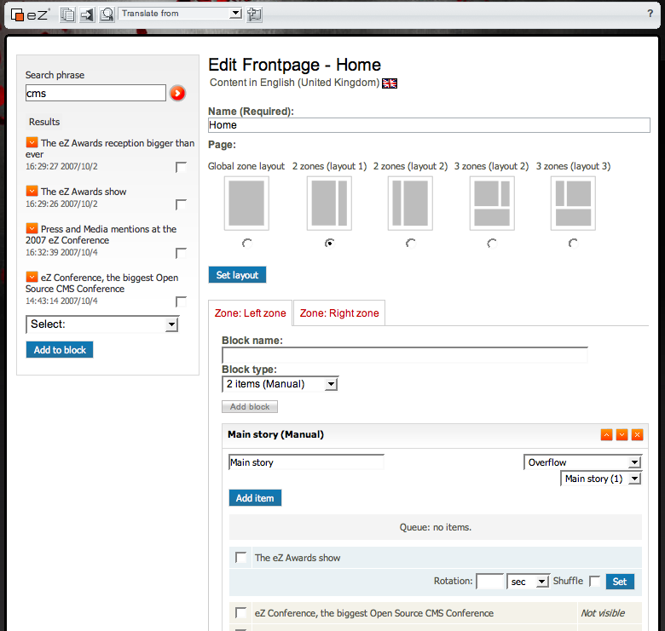

Zones
By default, eZ Flow has three layouts and six sample zones configured and ready for use. The diagram below shows the selection interface with the pre-configured layouts:
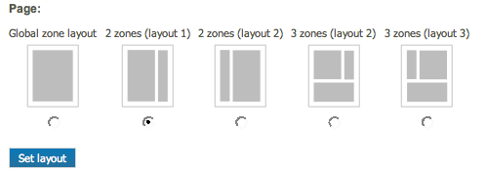

Creating blocks
To create a frontpage, an editor adds blocks within zones. Each zone is represented by a tab in the editing interface, as shown below.
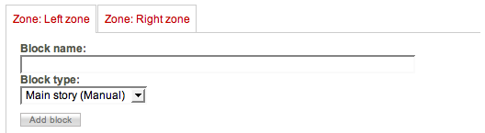
After selecting the tab that corresponds to a zone, you can start adding blocks. This is done by entering the name of the block, choosing the type of block you want to create and then clicking the Add block button. Describe how and where block types are configured
After the block is created, three lists are displayed: Queue, Online and History. The Queue list shows the items that are planned for publication. For each item in the queue, you can specify the number of minutes that will elapse before the item is published.
The Online list shows the items that are currently published and visible to site visitors. Each zone has a maximum number of items that can be displayed at one time (based on the
The History list shows the items that were previously published but are not currently visible. The number of items displayed in this list is based on the Zone’s configuration.
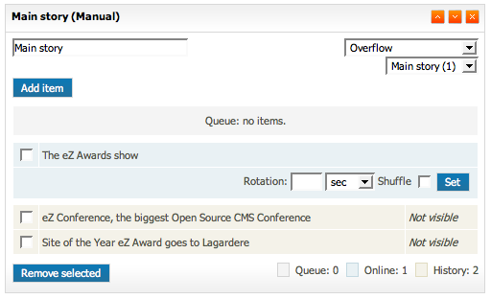

Overflow
The number of items a block can display at one time is limited. However, you can add an overflow rule that decides what happens in the case when an item no longer can be visible. The overflow dropdown gives you the choice of selecting any other block on the same page. When another block is selected this means that any items which is pushed out from the online list will be moved to the queue of the selected block.
This feature enables you to have a flow of content automatically via the blocks defined on your page.

Block templates
Multiple display styles may be available for a single block, depending on the configuration of the block type. The block template dropdown list shows the available styles for the given block. For example, a block for main stories might have two display variations as shown in the screenshots below:

Main story with large image.

Main story with large automatically cropped image.
The templates that are available for blocks are part of the block configuration.

Automatic rotation
If you add multiple items to the queue you have the ability to rotate the items which are currently online and in the queue. You can select the time interval for the rotation. If you want to randomize the order of the content rotation you select the shuffle checkbox.
This feature enables you to have the content on your frontpage automatically updated. This is useful if you run a news site and e.g. no editorial staff is on work during a weekend or holiday. The visitors will get the impression that new content is published since the page can change e.g. every 15 minutes.

Block position
The blocks can be moved up and down to position them at the desired spot on the page. To move a block simply click the arrows for up or down in the upper right corner of the block.

Adding content

Adding content to a block
Once the blocks are defined you are ready to add items. This can be done in two ways; either click the add item button which gives you a browse window or use the search bar on the left.
To do a search enter the search phrase in the search field and push entere or click the orange arrow next to the search field. This gives you the results for that search query. Tick off the items you want to make visible on your page the select the block to add them to. Finally push the add to block button.
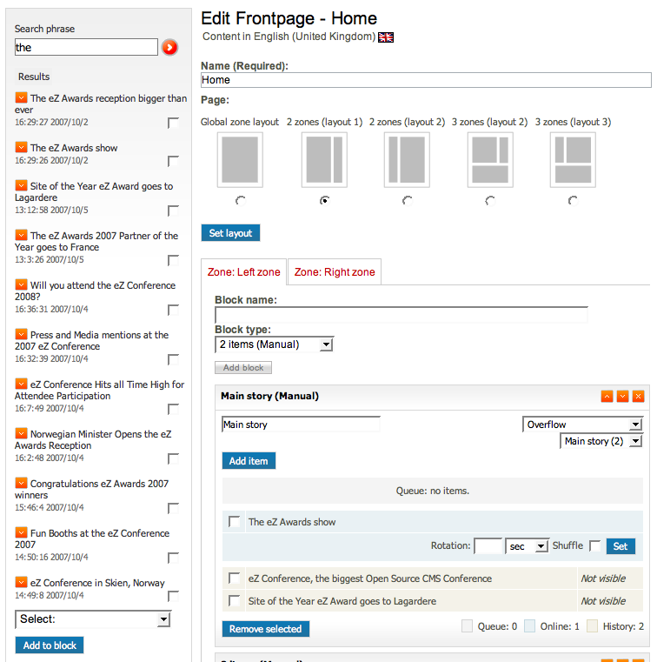

Timeline Preview
The timeline functionality gives you an actual preview of the page. Since the content on the page heavily changes based on time you have a slider at the top of the screen which enables you to preview the content at a given time in the future or history.
To select a specific time drag the slider to the desired position. The page will then automatically update with the content that is scheduled to be published at that time. The slider is optimized to give you a selection within a 24 hour period.

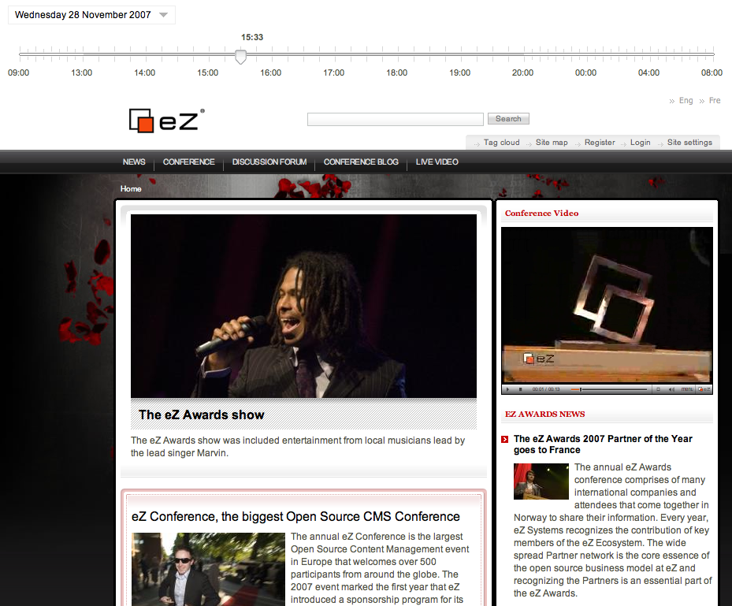
If you want to choose a preview further in the future click the data selection dropdown and choose in the calendar. The calendar shows the next 3 months by default. To choose other times navigate with the next and previous arrows in the calendar.
